|  |  |
| --- | --- |
|  | Foundation Activity2 Building an LED Circuit |

Contents and Learning Outcomes

Students will,

1. Read a basic circuit diagram
2. Build a circuit on a breadboard to turn on an LED

This activity should take **~1 hour (1.5 hours recommended)** to complete:

[Contents and Learning Outcomes 1](#_Toc517787480)

[Materials and Costs per Student 2](#_Toc517787481)

[Lesson 2](#_Toc517787482)

[Activity Overview (2 minutes) 2](#_Toc517787483)

[Review of Electricity (5 minutes) 3](#_Toc517787484)

[Reading Circuit Diagrams (10 minutes) 3](#_Toc517787485)

[Making Circuits on a Breadboard (10 minutes) 4](#_Toc517787486)

[Build the LED Circuit (30 minutes) 6](#_Toc517787487)

[Debrief Discussion (5 minutes) 7](#_Toc517787488)

[Challenge and Explore 7](#_Toc517787489)

[Frequently Asked Questions 9](#_Toc517787490)

Materials and Costs per Student

Assuming one kit of parts per student:

|  |  |  |  |  |
| --- | --- | --- | --- | --- |
| Item | Qty. | Cost per Student[1](#fn:1) | Expendable[2](#fn:2) | Supplier |
| Push Button | 2 | 0.04 | yes | [Aliexpress](https://www.aliexpress.com/item/Free-Shipping-100PCS-2-pins-6-6-5-mm-Switch-Tactile-Push-Button-Switches-6x6x5mm/1393753898.html?spm=2114.01010208.3.89.VeW6Y6&ws_ab_test=searchweb0_0,searchweb201602_3_10152_10065_10151_10130_10068_10139_10136_10137_10060_10155_10062_437_10154_10056_10055_10054_10059_303_100031_10099_10103_10102_10096_10052_10053_10142_10107_10050_10051_5030013_10084_10083_10080_10082_10081_10178_10110_519_10111_10112_10113_10114_10182_10078_10079_10073_10123_10189_142,searchweb201603_9,ppcSwitch_4&btsid=0ad2c9e1-e4e3-419e-8f32-c9bb7d9ded7c&algo_expid=5c4bcdb3-acce-4f8a-9f45-fbd33bf2db3b-11&algo_pvid=5c4bcdb3-acce-4f8a-9f45-fbd33bf2db3b) |
| LED 5mm or 3mm | 2 | 0.04 | yes | [Aliexpress](https://www.aliexpress.com/item/J34-Free-Shipping-1-set-200Pcs-3mm-5mm-LED-Light-White-Yellow-Red-Blue-Green-Assortment/32655072420.html?spm=2114.01010208.3.34.K24zLn&ws_ab_test=searchweb0_0,searchweb201602_3_10152_10065_10151_10130_10068_10139_10136_10137_10060_10155_10062_437_10154_10056_10055_10054_10059_303_100031_10099_10103_10102_10096_10052_10053_10142_10107_10050_10051_5030013_10084_10083_10080_10082_10081_10178_10110_519_10111_10112_10113_10114_10182_10078_10079_10073_10123_10189_142,searchweb201603_9,ppcSwitch_4&btsid=74f564e8-cf58-4fba-8b0c-d472d28c2ff7&algo_expid=b1394c0c-3084-49e8-8bfd-5efb17d393b7-4&algo_pvid=b1394c0c-3084-49e8-8bfd-5efb17d393b7) |
| Resistor, 2.2k Ohm, ¼ W | 1 | 0.01 | yes | [Aliexpress](https://www.aliexpress.com/item/Total-2100pcs-1-1-4W-Metal-Film-Resistor-Assorted-Kit-21-Values-1-Ohm-1M-Ohm/1065989389.html?spm=2114.01010208.3.49.E1lT47&ws_ab_test=searchweb0_0,searchweb201602_3_10152_10065_10151_10130_10068_10139_10136_10137_10060_10155_10062_437_10154_10056_10055_10054_10059_303_100031_10099_10103_10102_10096_10052_10053_10142_10107_10050_10051_5030013_10084_10083_10080_10082_10081_10178_10110_519_10111_10112_10113_10114_10182_10078_10079_10073_10123_10189_142-normal#cfs,searchweb201603_9,ppcSwitch_4&btsid=c29fad75-42b1-4f39-a439-a6d88e149c80&algo_expid=8316255e-6bd9-4140-b171-8a451ea8713a-6&algo_pvid=8316255e-6bd9-4140-b171-8a451ea8713a) |
| Jumper Cable, M/M | 4 | 0.07 | yes | [Aliexpress](https://www.aliexpress.com/item/Free-shipping-Dupont-line-120pcs-10cm-male-to-male-male-to-female-and-female-to-female/32714431608.html?spm=2114.13010308.0.0.FYFaeT) |
| 9V Battery Snap | 1 | 0.16 |  | [Aliexpress](https://www.aliexpress.com/item/Fast-shipping-UNO-R3-9V-Battery-Connector-9V-battery-clip-for-arduino-12pcs-lot-in-stock/1954763219.html?spm=2114.01010208.3.1.EedDHa&ws_ab_test=searchweb0_0,searchweb201602_3_10152_10065_10151_10130_10068_10139_10136_10137_10060_10155_10062_437_10154_10056_10055_10054_10059_303_100031_10099_10103_10102_10096_10052_10053_10142_10107_10050_10051_5030013_10084_10083_10080_10082_10081_10178_10110_519_10111_10112_10113_10114_10182_10078_10079_10073_10123_10189_142,searchweb201603_50,ppcSwitch_4&btsid=8e904185-6e84-42e6-b2e3-4c1c951dda29&algo_expid=1ce3b53a-b6bb-4b51-99be-2a97119d63bb-0&algo_pvid=1ce3b53a-b6bb-4b51-99be-2a97119d63bb) |
| Breadboard 400 point | 1 | 1.49 |  | [Aliexpress](https://www.aliexpress.com/item/Free-Shipping-10pc-Quality-mini-bread-board-breadboard-8-5CM-x-5-5CM-400-holes/1785291644.html?spm=2114.01010208.3.129.v6wyGQ&ws_ab_test=searchweb0_0,searchweb201602_3_10152_10065_10151_10130_10068_10139_10136_10137_10060_10155_10062_437_10154_10056_10055_10054_10059_303_100031_10099_10103_10102_10096_10052_10053_10142_10107_10050_10051_5030013_10084_10083_10080_10082_10081_10178_10110_519_10111_10112_10113_10114_10182_10078_10079_10073_10123_10189_142,searchweb201603_50,ppcSwitch_4&btsid=6cedbe6d-dc4c-47ed-b942-d4fef5789d54&algo_expid=ca53d8d6-1460-4def-9635-9a5d78155ba8-16&algo_pvid=ca53d8d6-1460-4def-9635-9a5d78155ba8) |
| Breadboard Power Supply | 1 | 0.75 |  | [Aliexpress](https://www.aliexpress.com/item/Best-price-10pcs-lot-MB102-Solderless-Breadboard-Power-Supply-Module-3-3V-or-5V/32505402973.html?spm=2114.01010208.3.121.o1lolF&ws_ab_test=searchweb0_0,searchweb201602_3_10152_10065_10151_10130_10068_10139_10136_10137_10060_10155_10062_437_10154_10056_10055_10054_10059_303_100031_10099_10103_10102_10096_10052_10053_10142_10107_10050_10051_5030013_10084_10083_10080_10082_10081_10178_10110_519_10111_10112_10113_10114_10182_10078_10079_10073_10123_10189_142,searchweb201603_50,ppcSwitch_4&btsid=ca59b36d-000d-43df-a83a-96852d809e96&algo_expid=f30d4306-9a10-4859-bd80-cc4729779eb5-15&algo_pvid=f30d4306-9a10-4859-bd80-cc4729779eb5) |
| 9V Ni-Mh 450mAh | 1 | 5.17 |  | [Aliexpress](https://www.aliexpress.com/item/Wholesales-8pcs-lot-ETINESAN-9v-450mAh-Ni-MH-Rechargeable-9-Volt-NiMH-Battery-Batteries-use-Camera/32535390438.html?spm=2114.01010208.3.170.Pujavd&ws_ab_test=searchweb0_0,searchweb201602_3_10152_10065_10151_10130_10068_10139_10136_10137_10060_10155_10062_437_10154_10056_10055_10054_10059_303_100031_10099_10103_10102_10096_10052_10053_10142_10107_10050_10051_5030013_10084_10083_10080_10082_10081_10178_10110_519_10111_10112_10113_10114_10182_10078_10079_10073_10123_10189_142,searchweb201603_50,ppcSwitch_4&btsid=7f174eeb-7335-4d1a-98d0-64862e5cf274&algo_expid=bc27a180-c5a4-4e39-bab4-c0693a22a2e0-21&algo_pvid=bc27a180-c5a4-4e39-bab4-c0693a22a2e0) |
| Total Cost per Student |  | **$7.75 CAD** |  |  |

1. *Currency is CAD, 2017-06-10. Assuming one set of parts per student.*
2. *Likely to be broken or lost during the activity.*

Each student should also get one printed copy of the activity handout.

Lesson

For further information see Arduino: Get to Know Your Tools*[[1]](#footnote-1)*

**Bold** text indicates directions or notes specifically for the instructor.

Activity Overview (2 minutes)

In the last activity we learned about how electricity works and tested conductors and insulators.

Today, we’re going to:

1. Review the fundamentals of electricity
2. Learn to read circuit diagrams
3. Learn about making circuits on a breadboard
4. Build an LED circuit

Review of Electricity (5 minutes)

**The following is a review of electricity that should be discussed with students to begin the lesson. Draw the hill diagram on the board and describe how this analogy works.**

* The height of the hill represents voltage
* The sliding rocks represent current
* Trees represent resistance
* Current always flows from high to low voltage

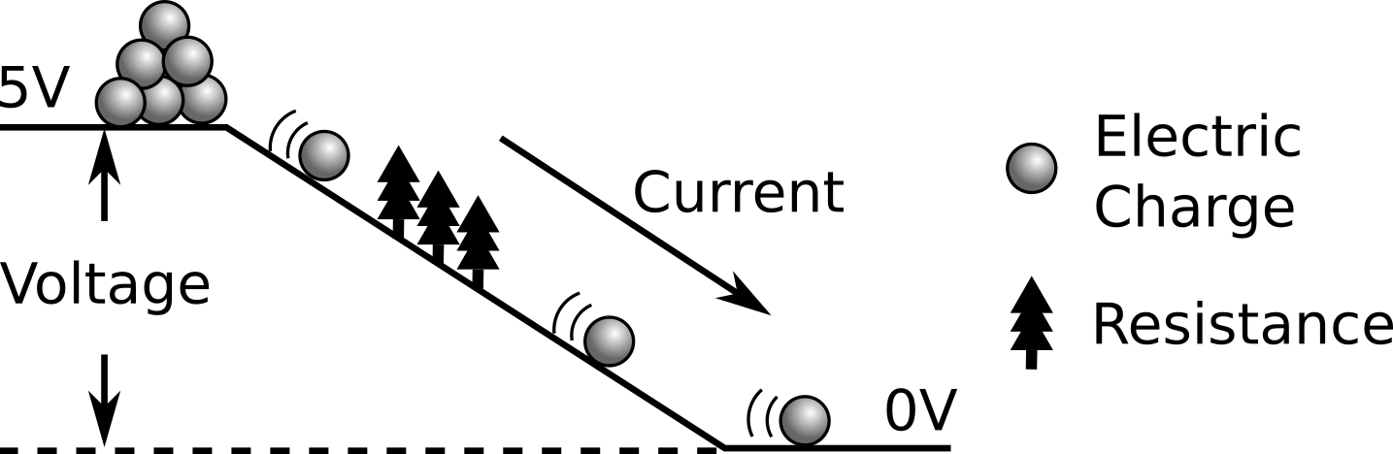

Reading Circuit Diagrams (10 minutes)

Circuit diagrams represent circuits using easy-to-draw symbols. **Introduce the following symbols and their corresponding real-world parts:**

|  |  |  |  |
| --- | --- | --- | --- |
| **Part Image** | **Symbol** | **Name** | **Description** |
| **C:\Users\Harryp\MEGA\Surface Pro 2\Nepal\Himalayan Makers Guild\Activities\Foundation Activities\FA2 - LED Circuit on a Breadboard\images\2018-04-29 17_48_15-Untitled Sketch.fzz_ - Fritzing - [Breadboard View].jpg[[2]](#footnote-2)** |  | *Battery* | The voltage source for the circuit. |
| **C:\Users\Harryp\MEGA\Surface Pro 2\Nepal\Himalayan Makers Guild\Activities\Foundation Activities\FA2 - LED Circuit on a Breadboard\images\part jumper.png** |  | *Wire* | A pathway for current to move along. |
| **C:\Users\Harryp\MEGA\Surface Pro 2\Nepal\Himalayan Makers Guild\Activities\Foundation Activities\FA2 - LED Circuit on a Breadboard\images\2018-04-29 17_48_25-Untitled Sketch.fzz_ - Fritzing - [Breadboard View].jpg** |  | *Diode* | Current will only flow in one direction, along the “arrow” shape. |
| **C:\Users\Harryp\MEGA\Surface Pro 2\Nepal\Himalayan Makers Guild\Activities\Foundation Activities\FA2 - LED Circuit on a Breadboard\images\2018-04-29 17_48_58-Untitled Sketch.fzz_ - Fritzing - [Breadboard View].jpg** |  | *Resistor* | Limits the flow of current through the circuit. |
| **C:\Users\Harryp\MEGA\Surface Pro 2\Nepal\Himalayan Makers Guild\Activities\Foundation Activities\FA2 - LED Circuit on a Breadboard\images\2018-04-29 17_49_04-Untitled Sketch.fzz_ - Fritzing - [Breadboard View].jpg** | **C:\Users\Harryp\MEGA\Surface Pro 2\Nepal\Himalayan Makers Guild\Activities\Foundation Activities\FA2 - LED Circuit on a Breadboard\images\symbol switch.jpg** | *Button* | Like a door for current to flow through. When the button is pressed, the circuit is connected and current will flow. |

Our aim is to combine these parts to build the LED light circuit shown in this diagram, so that when we press the button the LED light turns on:

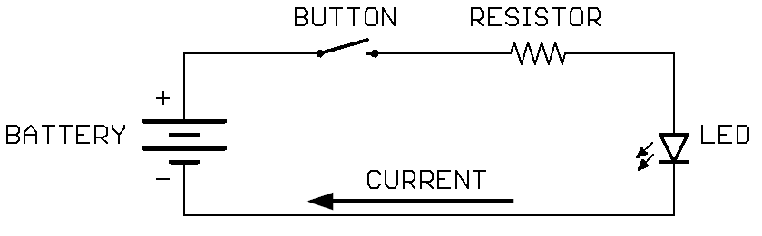

When the button is pressed, electricity will be able to flow from the (+) side of the battery, through the LED and resistor, to the (-) side. Electricity flowing through the LED will cause it to light up. The resistor is used to limit the current flowing through the diode, so that the diode does not burn out.

When parts are connected together with a line (wire) in a circuit diagram, we call that connection point a node. Two or more parts can be connected together in a node. How many nodes are there in this circuit diagram, and where are they? A: four nodes

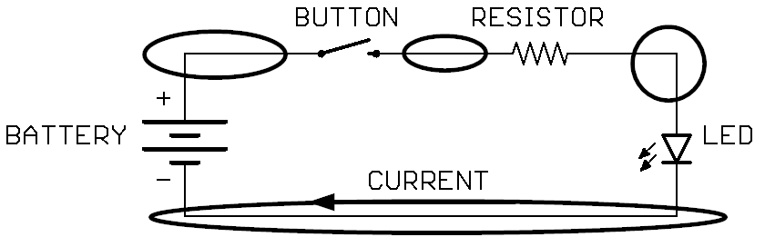

Making Circuits on a Breadboard (10 minutes)

**Introduce students to the fundamentals of building circuits on a breadboard with the following key points:**

* Breadboards are used to build circuits that can be put together and taken apart without needing special tools.
* Current flows along the lines as show in this diagram, usually in groups of 5 connection points. (**draw the diagram on the board**). Parts inserted into connection points on the same line are electrically connected by metal inside the board.

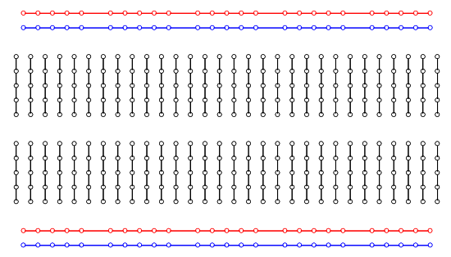

* The connection points along the lines on the outside of the board are all connected. They are usually used for the (+) and (-) from the voltage source. Usually the RED lines are used for the (+) and the BLUE lines are used for the (-).

**Draw the following diagrams on the board and ask the students the questions to test their understanding of the breadboard:**

|  |  |
| --- | --- |
| **Two wires inserted on different line.** Are they are connected? A: No, they aren’t in the same line! | **Two wires inserted on the same line.** Are they are connected? A: Yes, the wires are in the same line, making a node. |
| C:\Users\Harryp\MEGA\Surface Pro 2\Nepal\Himalayan Makers Guild\Activities\Foundation Activities\FA2 - LED Circuit on a Breadboard\images\breadboard example 3.jpg | C:\Users\Harryp\MEGA\Surface Pro 2\Nepal\Himalayan Makers Guild\Activities\Foundation Activities\FA2 - LED Circuit on a Breadboard\images\breadboard example 4.jpg |
| **Two parts inserted on different lines.** Are they are connected? A: No, they aren’t in the same line! | **Two parts inserted on the same line.** Are they are connected? A: Yes, the parts are in the same line, making a node**.** |
| C:\Users\Harryp\MEGA\Surface Pro 2\Nepal\Himalayan Makers Guild\Activities\Foundation Activities\FA2 - LED Circuit on a Breadboard\images\breadboard example 2.jpg | C:\Users\Harryp\MEGA\Surface Pro 2\Nepal\Himalayan Makers Guild\Activities\Foundation Activities\FA2 - LED Circuit on a Breadboard\images\breadboard example 5.jpg |
| **One part inserted with both ends inserted in the same line.** Is this okay? A: No. If the two pins of the LED are connected in the same node there will be no voltage difference between them, so no current will flow from the (+) pin, through the LED, and out the (-) pin (a flat hill in the rockslide analogy of electricity). If we connect this circuit to a voltage, current will flow around the LED through the low-resistance metal of the breadboard (like a wire). | |
| C:\Users\Harryp\MEGA\Surface Pro 2\Nepal\Himalayan Makers Guild\Activities\Foundation Activities\FA2 - LED Circuit on a Breadboard\images\breadboard example 1.jpg | |

Build the LED Circuit (30 minutes)

**Ask the students to build a circuit that lights up one LED, and is turned on by pressing a button. This is the circuit diagram (printed on the student handout) that they should try to assemble on the breadboard:**



**Provide the students with the following parts and have them start to try to build the circuit from the circuit diagram.**

* **one breadboard with the power supply attached**
* **one 9V battery with a snap connector for the power supply**
* **one LED, and one resistor (2.2k ohms)**
* **one push button**

**The completed circuit may look like this:**

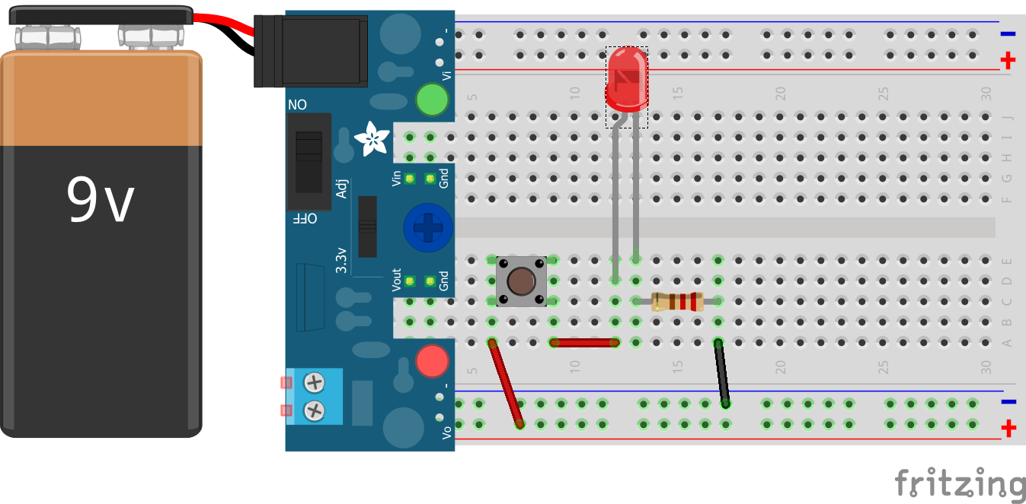

DebriefDiscussion (5 minutes)

**Encourage a discussion among the students for them to share their thoughts on the activity.**

Today we built an LED circuit. Why is this important? What applications does this have? Possible answers:

* We can control electricity using circuits to do things like turn lights on and off
* The circuit we built works similarly to normal indoor lights
* We could use the same kind of circuit to turn other things off and on, like a buzzer

What worked? What didn’t work? Why didn’t it work? What could we do next, or how could we make the circuit better?  
Possible Answers:

* Make the light brighter
* Power the circuit from a battery
* Make the circuit smaller
* Use a switch instead of a button to keep the light turned on/off

Challenge and Explore

**If a student completes the lesson early, evaluate their understanding by asking them to try the following:**

* Use a 2nd LED and make both LEDs turn on when the button is pressed. “What happens to the brightness of the LEDs when you do this? Can you draw the 2nd LED into the circuit diagram?”
  + Skills: reading circuit diagrams; building breadboard circuits.

This can be accomplished in two ways: LEDs in series or LEDs in parallel.

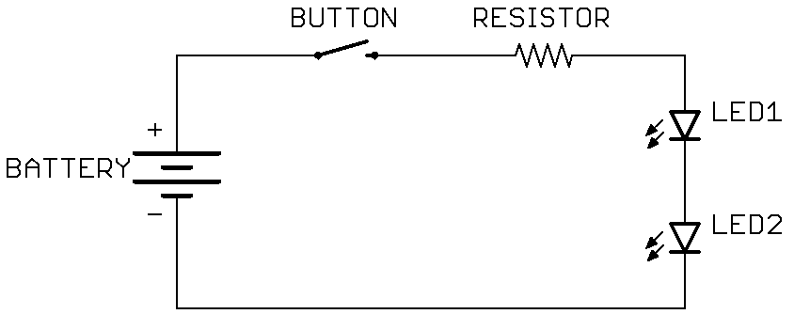

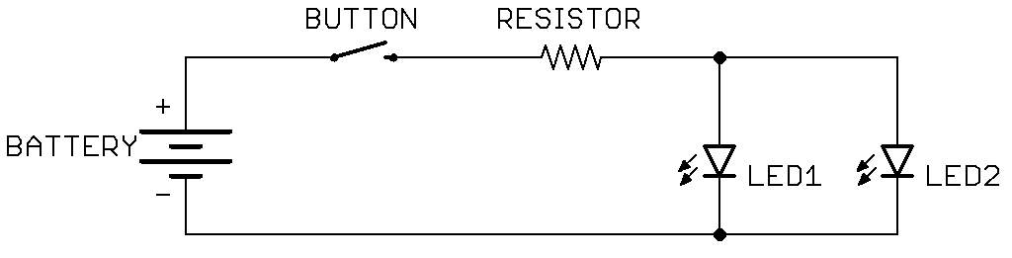

* Add a 2nd button and try to connect them so that both buttons must be pressed to turn on the light. Try drawing the 2nd button into the circuit diagram.
  + A:

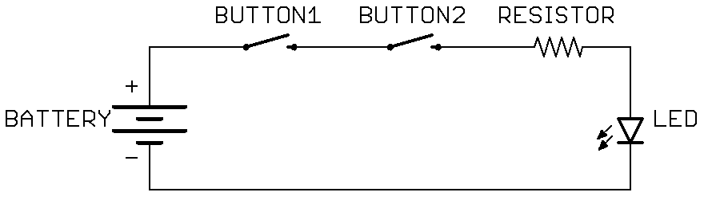

* Try using two buttons in the circuit so that pressing either button will turn on the light. Try drawing the 2nd button into the circuit diagram.
  + A:

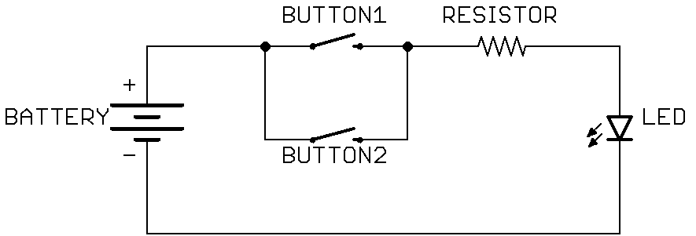

Frequently Asked Questions

* Why isn’t my light turning on when I press the button?   
  A: check the polarity of the LED and make sure that the (+) side will is connected towards the (+) on the breadboard, and similarly for the (-) side.   
  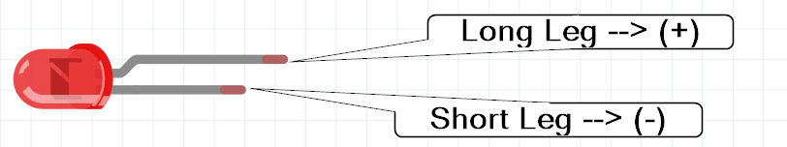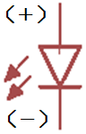  
  A: Make sure the power supply is on and on the breadboard in the correct direction with the (-) from the power supply on the blue line of the breadboard:  
  CORRECT:  
  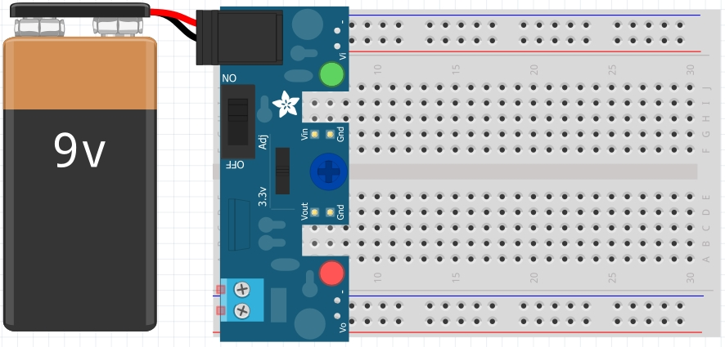  
  INCORRECT:  
  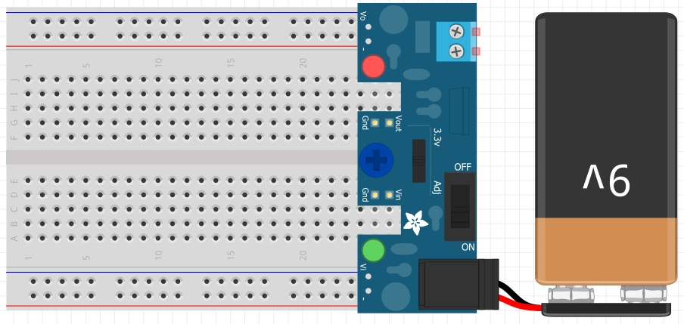  
  A: check to make sure the LED isn’t burnt out by trying it in a friend’s circuit that is already working.

1. https://www.youtube.com/watch?v=grU7eNPBRxk&index=1&list=PLT6rF\_I5kknPf2qlVFlvH47qHvqvzkknd [↑](#footnote-ref-1)
2. Part images from Fritzing, except the wire. [↑](#footnote-ref-2)